Morgan LESKERPIT 82223600

NonLinearDynamics

Final Assignment

Code repository : <https://github.com/Kraquant/NonLinearDynamicsFA.git>

Contents

Exercise 1 : Symmetry analysis 2

Q1.1 2

Q1.2 3

Exercise 1 : Hamiltonian dynamics 5

Q2.1 5

Q2.2 5

Q2.3 5

# Exercise 1 : Symmetry analysis

## Q1.1

We can use the Linearized Symmetry Condition. For that we need to check if:

constantly holds for x and y.

We can conclude that the LSC is verified. Thus, v generates a group of symmetries for the ODE

## Q1.2

We are trying to solve the ODE using canonical coordinates:

where

Then we can write:

Or we know that:

The equations can easily be solved using the first integral which gives some particular solutions:

Then we need to find the relationship between r and s:

Then we can change variables for x and why to finally solve the system:

This is a second order equation. The value of y depends on the value of delta. We are looking for solutions where delta is strictly positive.

# Exercise 1 : Hamiltonian dynamics

## Q2.1

Hamilton’s equations are written as follows:

## Q2.2

To find the Hamiltonian level curves, we use the property that

We can then draw H for different values of H

In the following figure, the equation is traced for values of E ranging from -1 to 1.

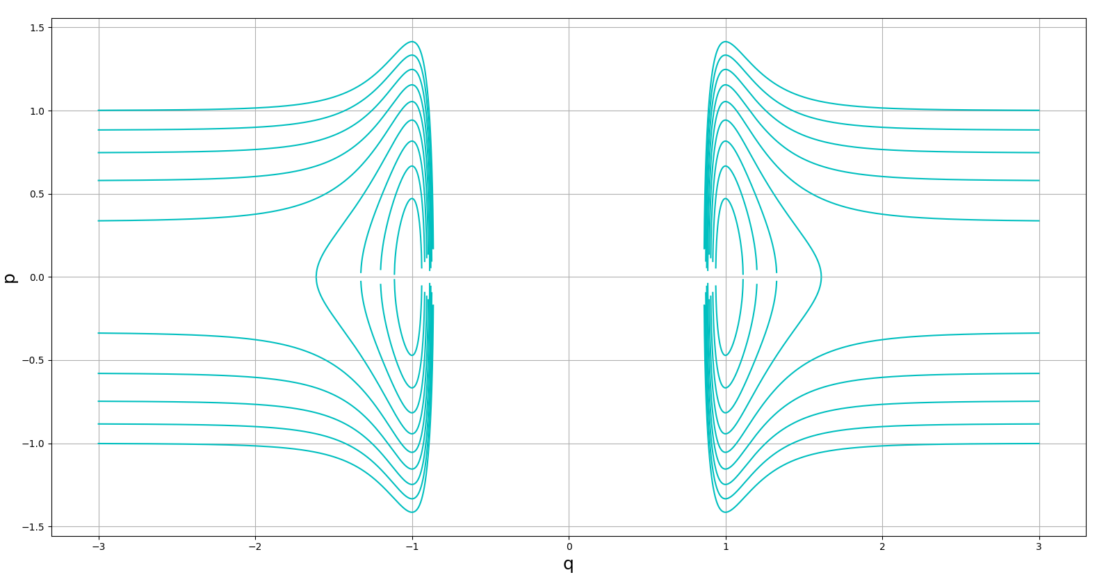

*Phase portrait for*

*Python file: phasePortrait.py*

We can see some closed shapes revolving around the value of [-1, 0] and [1, 0] when H stays quite low. When H gets higher, this behavior is changing.

## Q2.3

To solve the system numerically I didn’t know which initial values of p and q I should take. I started with p0=0 and q0=0 but the results were diverging. I looked up on the internet and realized that I had already studied this potential function V. If we trace V(q) we get the following result:

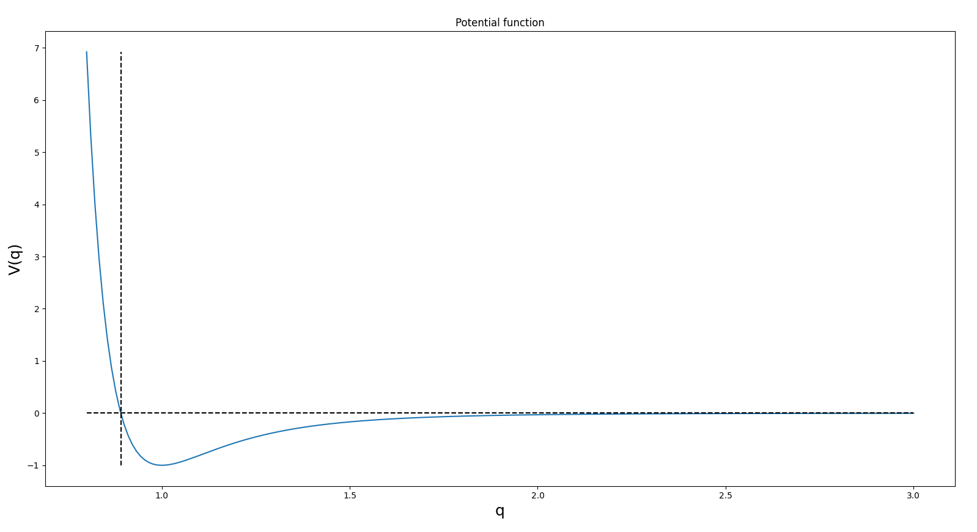

*Python file: potentialCurve.py*

To have a stable result, the initial value of q must be located in the hollowed part of the curve. So, I took a value of q0 higher than the theorical value where which is .

Thus, for every graph that is presented in the following section. The parameters are the following:

t0 = 0

tf = 4

steps = 300

q0 = 0.9

p0 = 0

eps = 1

If you want to check the result by yourself, please launch the file numericalSolver.py you will be asked in the command prompt which numerical method you want to preview. Just answer ‘y’ or ‘n’ when asked.

* Euler A and B methods

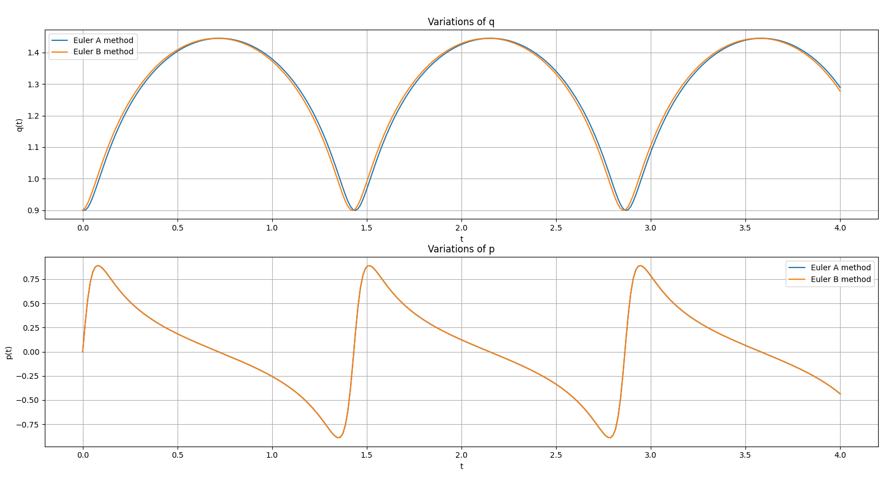

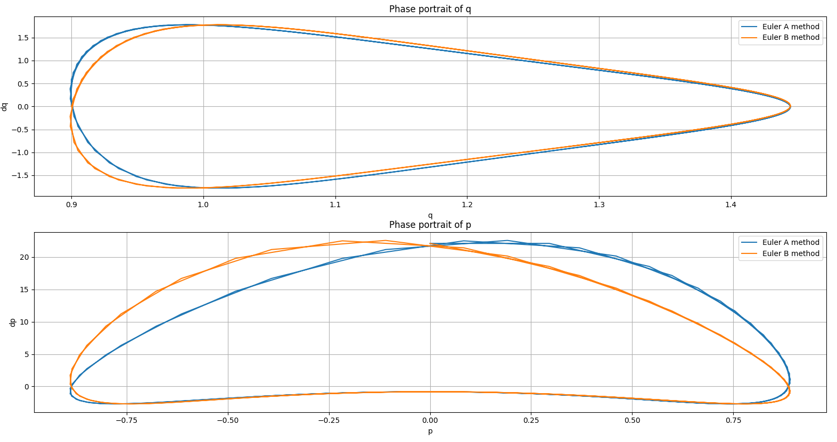

* SV-AB and SV-BA method

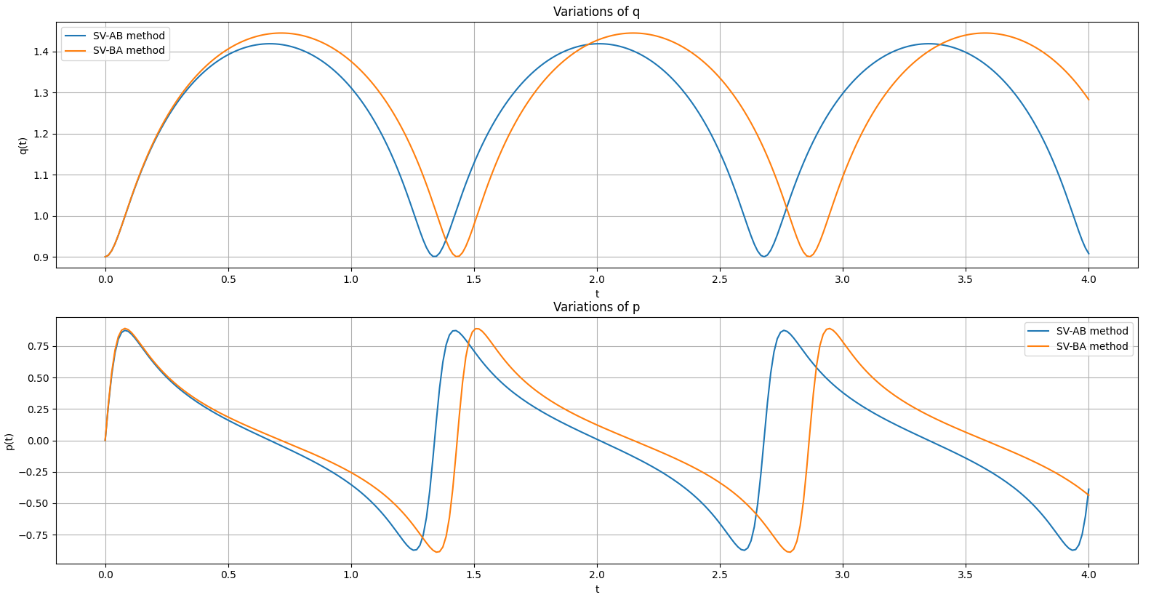

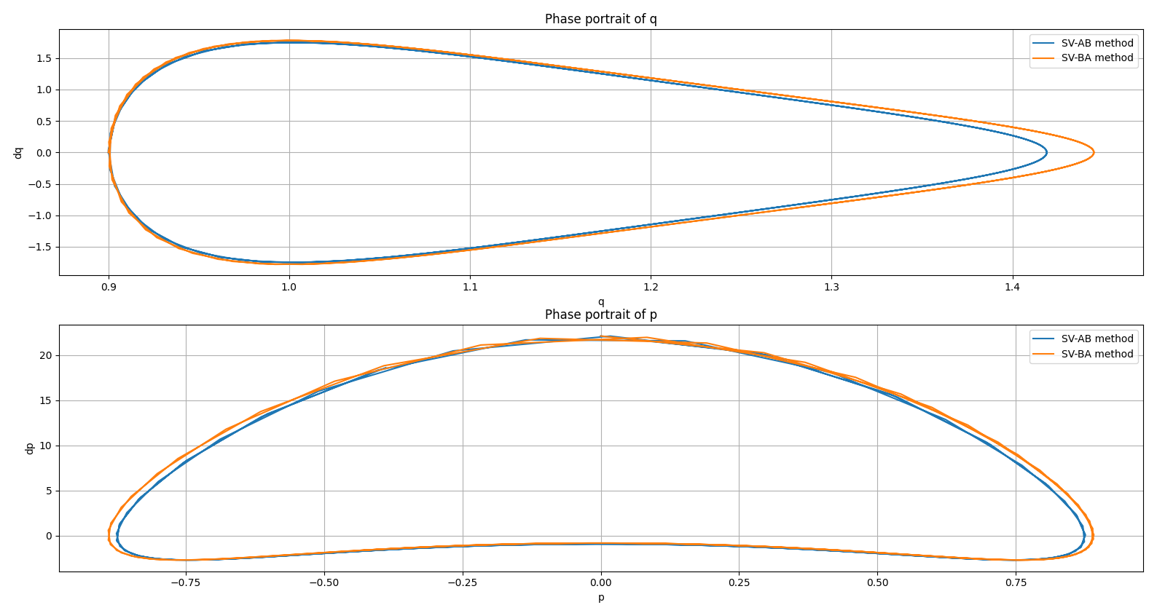

* Euler Forward method

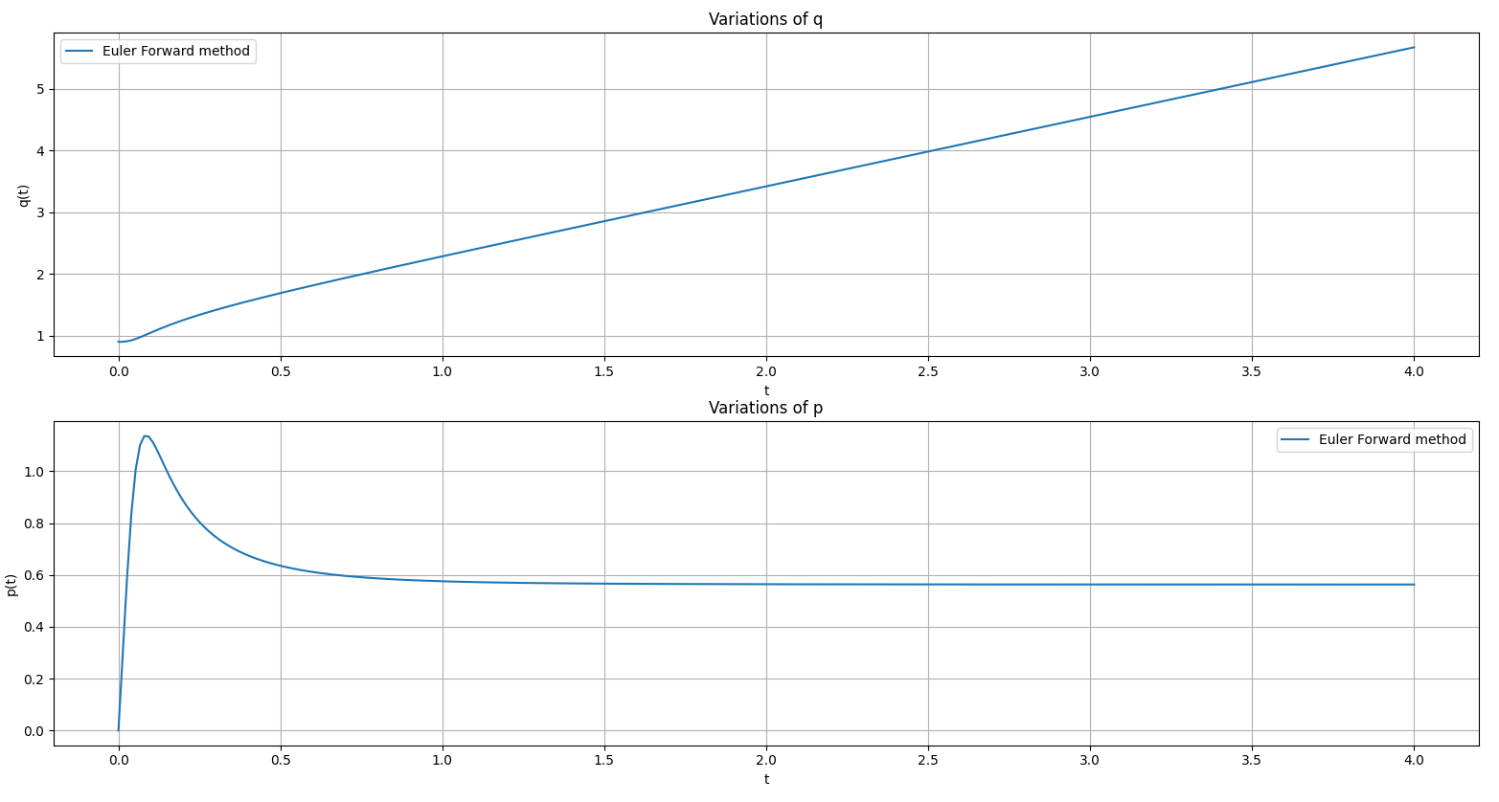

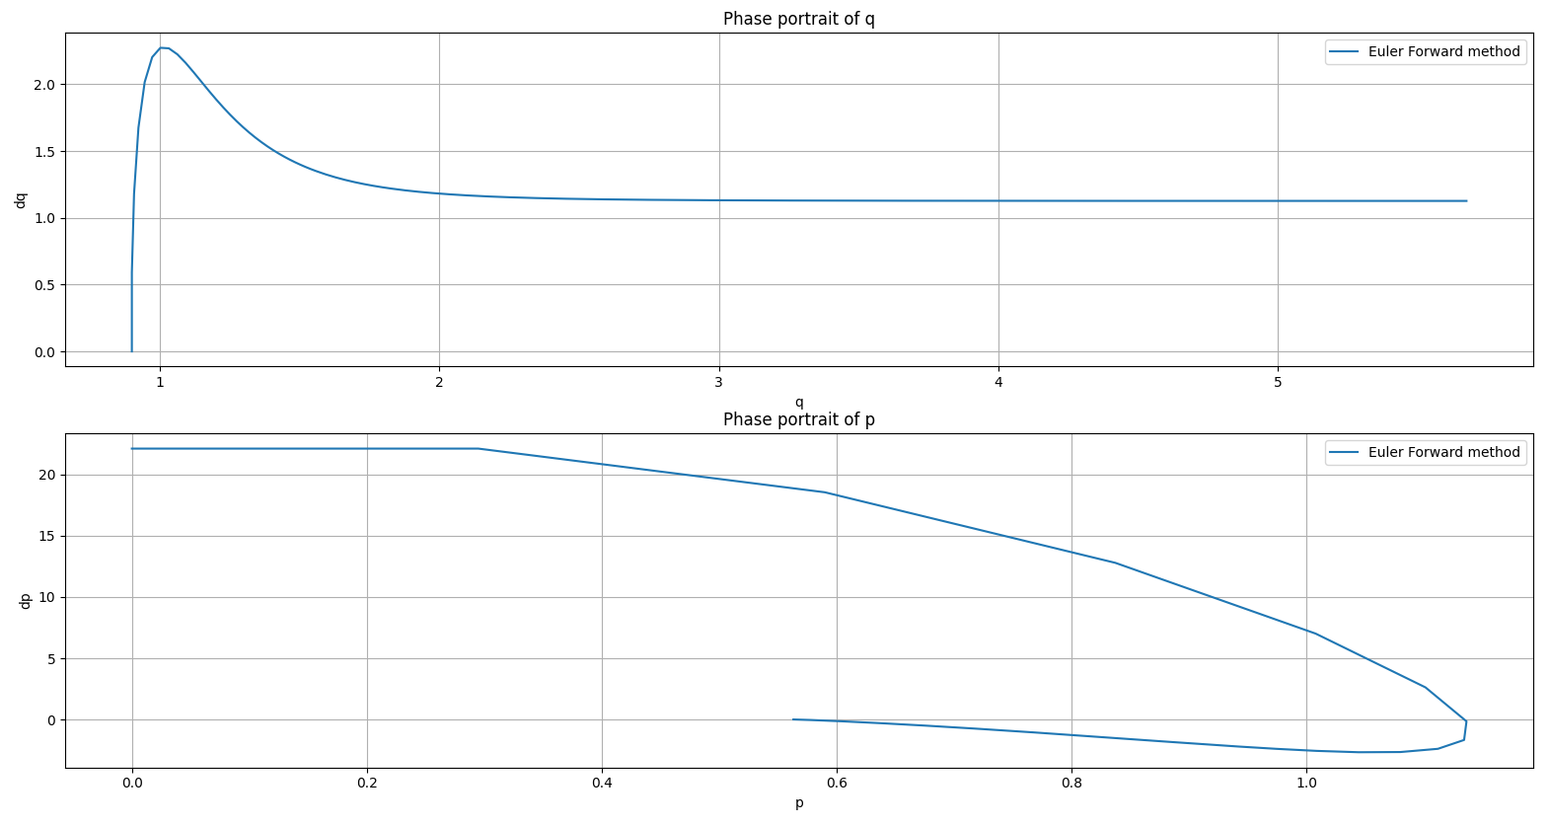

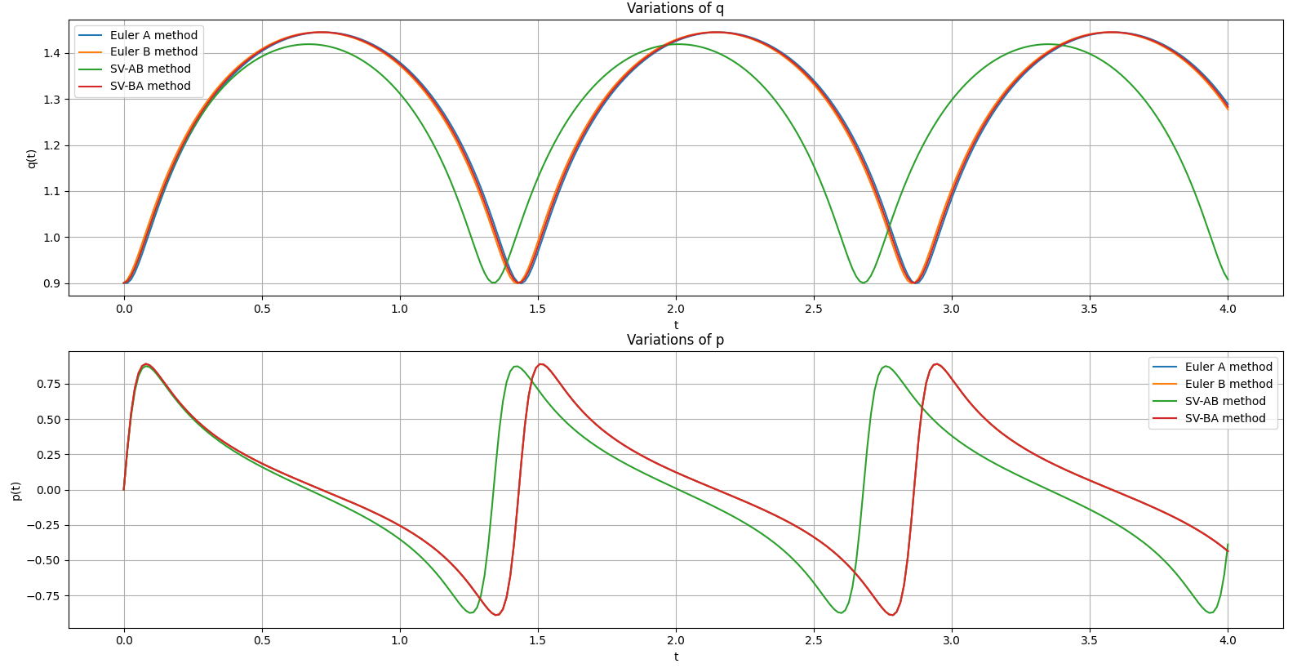

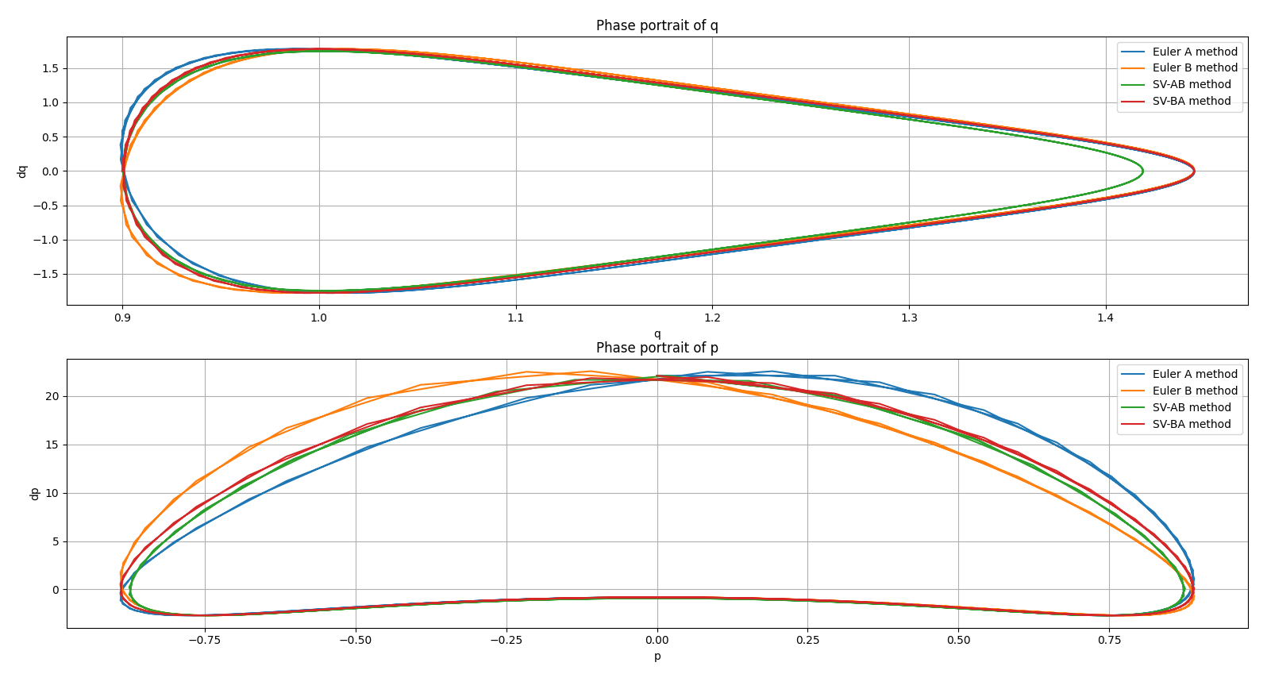

From the previous graphs we can see how efficient the Euler A/B and SV-AB/BA schemes are. We can manage to integrate the equations and get the oscillations without any apparent divergence. On the other hand, the forward Euler method didn’t work at all for these equations. Diverging even before the first period of oscillation.

When we take a look at the phase portraits for the symplectic integrators, the curve is a nice closed shape which means that the energy is conserved as it should be. We can however note some shape differences between the methods. But we can clearly see that the SV-AB/BA methods are a combination of the Euler A and B method. Indeed, the SV-AB/BA phase portraits curves seem to average the differences that we get between the Euler A and B curves.